Activity | Description | Resources Required | Bible Focus
1 | Jesse Tree | Tree  Cards/Paper | God’s family
2 | Christmas Cards |  | Sharing the good news
3 | Advent Calendar |  | Preparing for Jesus
4 | Advent challenges  Dancing Cranberries  watch the cranberries in lemonade going up and down – find out the science of the ups and downs of the cranberries, who might be feeling down at Christmas, how could you help them?  Edible Candle  Decorate the biscuit with the shape of a candle – How could you share God’s Christmas Light? In our parties and nativities, in preparing and sharing our meals, in the shops and in the hospitals, in the places we make Christmas real.  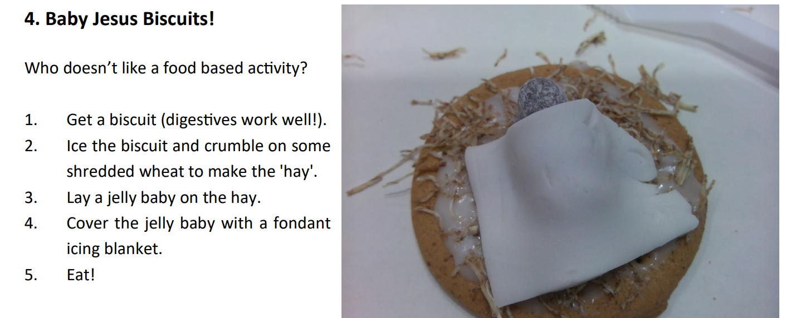 | Cranberries  Lemonade  Jar  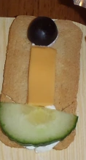  Ryvita  Cheese  Cucumber  Grape  Digestive  Shredded Wheat  Jelly Babies  Fondant Icing  Water Icing | How could you share God’s Christmas Light?
5 | Christingle  https://www.haebea.org/lib/how-to-make-a-christingle-F181516.pdf | Oranges  Candles  Cocktail Sticks  Red Ribbon  Sweets | How could you share God’s Christmas Light?
6 | Advent Paper Chain  https://happyhomefairy.com/advent-paper-chain-countdown-free-printable/ | Printed poem  Red / Green paper strips  Glue / Sellotape / Stapler | How could you share God’s Christmas Light?
7 | Advent Wreath  https://www.catholicicing.com/advent-wreath-craft-for-catholic-kids/ | Green Pipe cleaners  Yellow Pipe Cleaners  Green Tulle  Pony Beads (any colours) | How could you share God’s Christmas Light?
8 | Star  https://familygodtime.wordpress.com/2016/12/08/follow-the-star-2016-yarn-wrapped-star/ | Card template  coloured wool  Scissors | How could you share God’s Christmas Light?
9 | Angel  https://pin.it/6hY59Nv8b | White paper  Glue  Thread  Bead
10 | Nativity  https://biblecraftsandactivities.com/nativity-craft/ | Paper cut outs  Glue  Black background
Knitted Nativity

Nativity Stories

