Activity | Description | Resources Required | Bible Focus
1 | Obstacle Race  How quickly can you complete the course?  Can you complete it faster with a heavy bag? | Stopwatch (phone)  Hoops, Ropes, Cones, etc  Heavy backpack  Sheet to record the results | Perseverance
2 | Edible Medals  Decorate biscuits which will be seen as medals  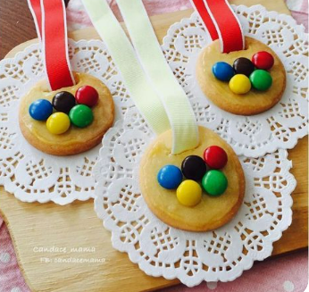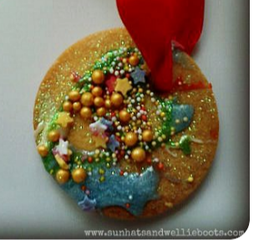 | Biscuits  Icing  Writing Icing  Knives, Bowls, Blue Roll  Pen (to write names)  (Smarties to show the flag)  Wipes | Success
3 | People Who Help Us  Create a mural of people who help us | Long strip of paper  Precut people  Fabric, wool, glue, pens, scissors | Support
4 | Outdoor Olympic Rings  Create the Olympic rings using outdoor materials | Outdoors  Picture of Olympic Flag for reference | People coming together
5 | Olympic Prayers  Paper Chains – prayers can be written in the Olympic colours  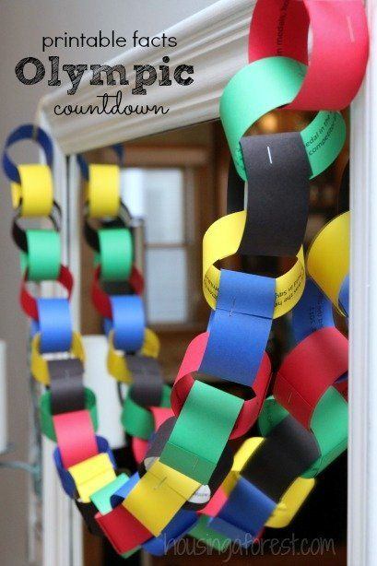 | Strips of paper in red, blue, yellow, green, black  Pencils (including white)  Glue (Pritt Stick)  Sellotape | Respect, excellence, friendship, courage, determination, inspiration, equality
6 | Olympic Torch  https://www.funlovingfamilies.com/olympic-torch-craft-kids/  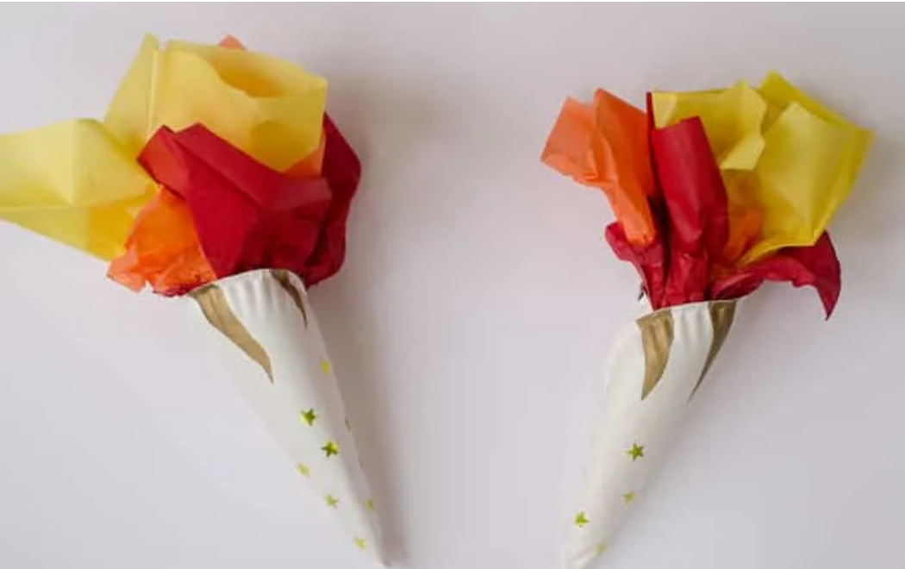 | Paper Plates  Tissue Paper  Sellotape  Gold stars  Stapler  Gold pen  Scissors  Glue | Peace and Friendship
7 | Olympic Torch  https://www.cbc.ca/parents/food/view/olympic-snack-fruit-torches  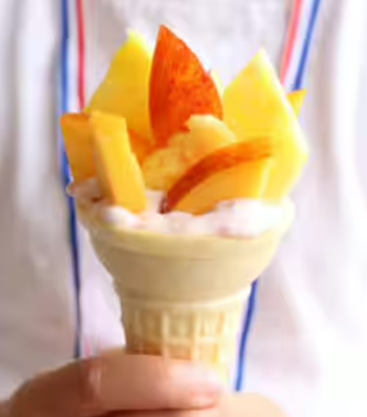 | Cones, cream, fruit  Cutlery, bowls, etc.  Wipes | Peace and Friendship
8 | Olympic Rings  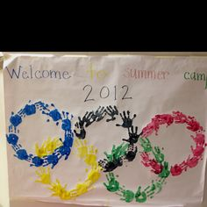  Cut out hands using coloured paper | Coloured paper in blue, black, red, yellow and green  Pencils  Scissors  Glue  Large paper to stick hands to | Respect, excellence, friendship, courage, determination, inspiration, equality
9 | Keeping in shape  How many bean bags in a bucket?  How long can you stand on one foot?  How long can you skip for?  Etc?? | Bean bags, ropes, buckets, space hoppers, etc  Sheet to record the results | Perseverance
10 | Olympic Ring Art  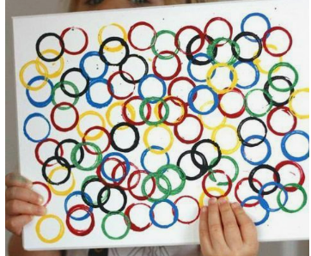 | Paint in blue, red, green, yellow, black  Circular things to print with  Aprons  A4 paper to paint onto  Wipes | God’s love is never ending

